November 21, 2015

To Whom It May Concern:

This is a letter of recommendation for Mr. Anthony Meunier

I have known Anthony for one term as he was a student in my CIS course at DeVry. His skills and abilities in how he commands Computer Information Systems show great potential for this new undertaking of his. Anthony had mentioned to me his future intentions of employment. One of the questions you may ponder is whether or not this person is qualified.

Please rest assured that any decision that you make in favor of Anthony would definitely be worth it. Anthony is extremely committed to achieving his goals. He is bright, intelligent and always has a pleasant attitude. He has outstanding leadership and human relations’ skills. His peers look up to him. He has set a precedent for this institution that is an example for other students to follow. I strongly recommend that you consider Anthony because I can’t think of anyone this academic school year more deserving of this opportunity.

If there are any other questions in which I could assist you in your decision making process, please feel free to contact me.

Sincerely,

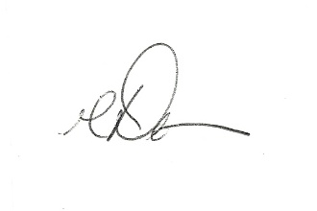

David A. Thomas, Ed.D.
Visiting Faculty
College of Engineering and Information Sciences

DeVry University
3005 Highland Parkway
Downers Grove, IL 60515-5799
dthomas8@devry.edu
909 643 3472



